**Ideation Phase**

**Define the Problem Statements**

|  |  |
| --- | --- |
| Date | 16 October 2022 |
| Team ID | PNT2022TMID31210 |
| Project Name | Deep Learning Fundus Image Analysis for Early Detection of Diabetic Retinopathy |
| Maximum Marks | 2 Marks |

**Customer Problem Statement :**

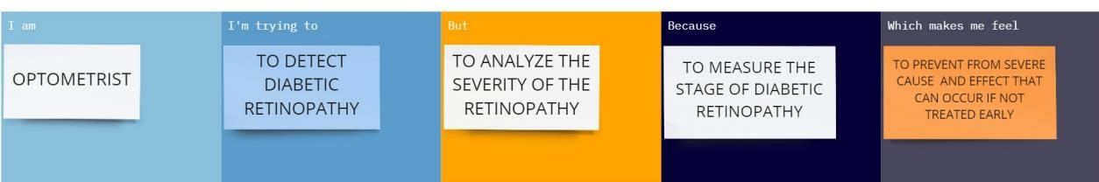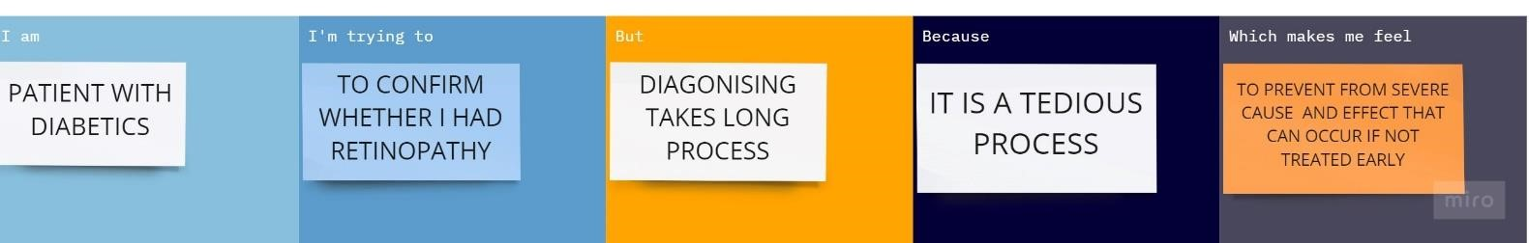

|  |  |  |  |  |  |
| --- | --- | --- | --- | --- | --- |
| **Problem Statement (PS)** | **Iam (Customer)** | **I’m trying to** | **But** | **Because** | **Which makes me feel** |
| PS-1 | Optometrist | To detect diabetic retinopathy | To analyze the severity of the retinopathy | To measure the stage of diabetic retinopathy | To prevent from severe cause and effect that can occur if not treated early |
| PS-2 | Patient with diabetics | To confirm whether i had retinopathy | Diagonising takes long process | It is a tedious process | To prevent form severe cause and effect that can occur if not treated early |